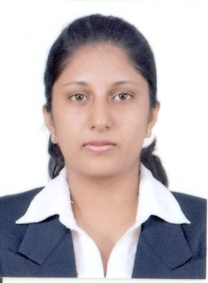

T.DILINI MADUWANTHI PEIRIS
NO: - 26/2A Kuduwamulla Rd, Katubedda,
Moratuwa, Sri Lanka.
Tel: +94716326847/+94718541129- Email: peiris_d@ymail.com

Personal Details

- Date of Birth : 20th of March 1990
- Sex : Female
- Nationality : Sri Lanka
- Religion : Catholicism
- Province : Western
- District : Colombo
- Civil Status : Single
- School Attended : Princess of wales’ college.
- NIC No : 905801627 V

Educational Qualifications

- G.C.E Ordinary Level Examination in 2006
Subject Grade
Mathematics A
Social Studies A
Business St. & Accounting A
Catholicism A
English B
Sinhala B
Dancing B
Geography B
Science & Technology C
Development Studies C
- G.C.E Advanced Level Examination in 2010
Subject Grade
Combined Maths S
Physics S
Chemistry S
General English S

Working Experience

- I have One year & three months working experience in Sri Lankan apparel industry in Brandix apparel Ltd, including below working categories.
  - Was a production & Finishing Recorder (Data & systems entry operator) at Brandix Casual wear Ltd Rathmalana.
- I have eight Months working experience in Etisalat Lanka Pvt Ltd, as a coordinator.
- I have one year working experience as an Account Assistant in York shipping Pvt Ltd.

Professional Qualifications

- Following a Diploma in Computerized Accounting at ESOFT.
- Followed a Computer Course in (MS Office XP 2007) at NAITA, Katubedda.
- Was a member of the school Science society in 2008.
- Was a member of the school Catholic society in 2008.
Career Objective

- To be one of the best professionals, acquiring best particles and knowledge relevant to it.
- I am right brain driven, hand working team player who likes to take up challengers and balance the life in between many tasks and roles.
- A team worker.

Non Related Refries
Fr. Tiron,
Queen of Angels Church,
(Rawathawatta Parish)
Katubedda,
Moratuwa.
Tel- +9411-2655462

Mr. Nihal Battegoda,
Retired Principal (J.P All Island),
36, Kuduwamulla Rd,
Moratuwa.
Tel- +9411-2655218

I do hereby certify that the above particulars are true and correct for the best of my knowledge.

Signature: Dilini Peiris Date: --------------

